screenshots
date | 4 march 2026
Team id | SWTID-2026-2438
Project name | Automating data import and relationship using import set&dot walking
Maximum marks | 4 marks
This project focuses on automating the process of importing external data into the Service Now platform using Import Set and Transform Map. In many organizations, large amounts of data come from external sources such as Excel or CSV files. Manually entering this data into the system can take a lot of time and may lead to errors.
To solve this problem, the project uses Import Set tables to temporarily store the imported data and Transform Maps to map the fields from the import table to the target table. This process automatically transfers the data to the correct fields and maintains proper relationships between records.
By automating the data import process, this project reduces manual work, improves data accuracy, and saves time for organizations using Service Now.

STEP:1
This screen shows the process of uploading an external data file into the ServiceNow platform. The uploaded file will be used for importing records into the system.
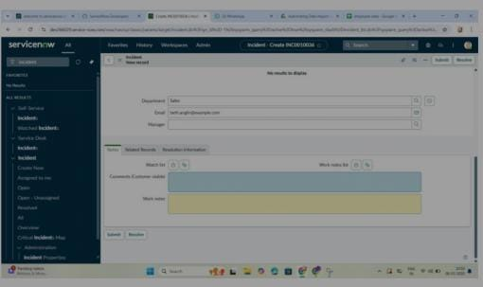
STEP 2:
This screen shows the Import Set table where the uploaded data is stored. The table temporarily stores the imported data before it is transformed into the target table.
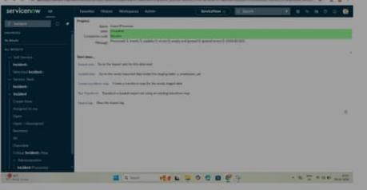
STEP 3:
This screen shows the creation of a Transform Map. The Transform Map is used to map fields from the Import Set table to the target ta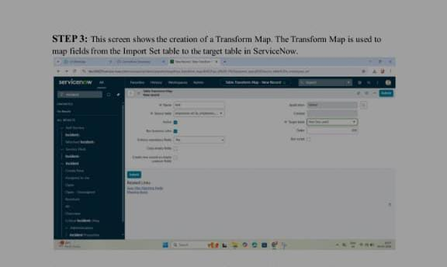

STEP 4:
In this step, fields from the Import Set table are mapped to the corresponding fields in the target table. This ensures that the data is transferred correctly.
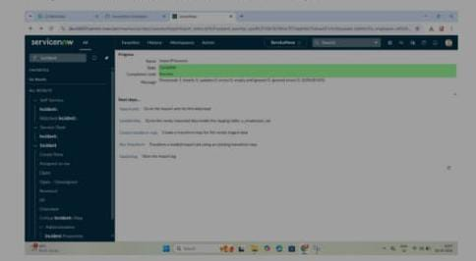

STEP 5:
This screen shows the execution of the transform process. The system moves the data from the Import Set table to the target table automatically.
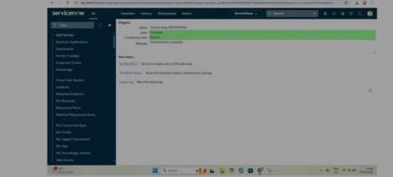

STEP 6:
This screen displays the final result after the transform process. The data is successfully imported into the target table and the relationship mapping is completed.

